

Kindergarten School Supply List
2026-2027 School Year

Please label everything!

- 8 Elmer’s glue sticks
- 1 round-tip scissors (Fiskar’s preferred)
- 24 #2 pencils (Ticonderoga)
- 8 - 24 count Crayola crayons
- 4 - package washable thick Original Colors Crayola Washable markers
- 1 - 4-packs dry erase marks
- 3 boxes of Kleenex
- Shoe-size (6 qt) rubbermaid bin
- Pencil box (See picture below)
- 1 pair durable headphones - Chromebook compatible
- 1 - ½ -inch binder
- Velcro Shoes (if your child cannot tie own shoes)
- Extra clothes for school
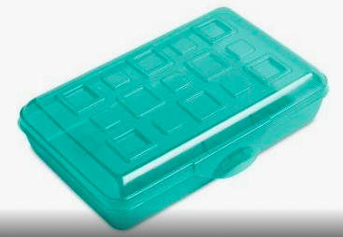
- 4 - Clorox Wipes
- 4 - Paper Towels
- Sandwich Ziplock Bags
- Gallon Ziplock Bags
- Pack of Playdough
- Watercolor
- Sidewalk Chalk

For Science:
- Box of Pencils
- Box of Crayons
- Box of Markers

