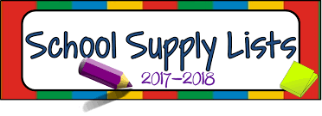
Kindergarten

- 4 dozen #2 yellow pencils (No mechanical pencils)
- 4 glue sticks
- 4 boxes of Crayola crayons (24 pack)
- 4 Clorox disinfectant wipes
- 4 boxes of tissues
- 4 plastic pocket folders (red, green, blue, yellow)
- 2 packs of dry erase markers (4 count)
- 2 pink erasers
- 2 packs of index cards (3 x 5)
- 2 bottles of hand sanitizer
- 1 pack of zip lock bags (if last name ends in A-M: sandwich sized baggies; if last name ends with N-Z: gallon sized baggies)
- 1 pair of scissors
- 1 pair of headphones- NO earbuds (Scholar’s name will be
labeled on them)

